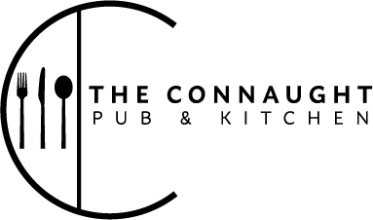

Roasts served until 6.30pm

Roasts
28 day aged roast sirloin of beef (served med-rare) 15.50
Skin on roast chicken breast, marinated in lemon, yogurt & herbs 14.00
Slow roast pork belly, homemade apple sauce & crackling 14.00
Red lentil, walnut & carrot loaf (vegan) 13.50
Roast cauliflower steak, in rosemary, garlic & thyme (vegan) 13.50
Three meats, beef, pork, chicken 17.50
Half portion of any roast (excluding lamb shank & Three meats) 8.50

All roasts come with garlic & rosemary roast potatoes, honey glazed carrots & parsnips, buttered kale, green beans, Yorkshire pudding & gravy

Sides
Baked cauliflower cheese (v) 4.00
Marmite roast potatoes (v) 4.00
Pigs in blankets, gravy 4.00

Desserts
Chocolate Guinness cake, Chantilly cream, strawberries (v) 6.00
Sticky toffee pudding, toffee sauce, vanilla ice cream (v) 6.00
Biscoff cheesecake, rhubarb coulis (vg) 6.00
Ice Creams (v) one scoop 3.00/ two scoops 5.00 / three scoops 6.00
(Vanilla, chocolate, strawberry, honeycomb, salted caramel)

